Prism-Based Subtraction

Definition
# Source: AI Source: Provided by: [Data Path: Persons Table -> ID Column: 1, Name_En Column: Motasem Essam] -> From: [ChatGPT] on [7/25/2026]
Prism-Based Subtraction is a type of composite solid formed by removing one or more portions from an original prism or prism-based solid.
The removed portions may have different geometric shapes, dimensions, and orientations. They can be removed from the faces, edges, corners, or interior of the original prism to create a modified three-dimensional structure.
The removed portions may include:
- Smaller prisms.
- Cubes.
- Rectangular prisms.
- Triangular prisms.
- Cylinders.
- Cones.
- Pyramids.
- Other geometric shapes.
Examples include:
- A rectangular prism with a rectangular block removed.
- A cube with a smaller cube-shaped cavity.
- A prism with a triangular notch.
- A rectangular prism with a cylindrical through-hole.
- A prism with several cutouts along its edges.

Simple Definition
# Source: AI Source: Provided by: [Data Path: Persons Table -> ID Column: 1, Name_En Column: Motasem Essam] -> From: [ChatGPT] on [7/25/2026]
Prism-based subtraction is the process of removing one or more geometric portions from a prism to create a new solid shape.

Geometric Representation
# Source: AI Source: Provided by: [Data Path: Persons Table -> ID Column: 1, Name_En Column: Motasem Essam] -> From: [ChatGPT] on [7/25/2026]
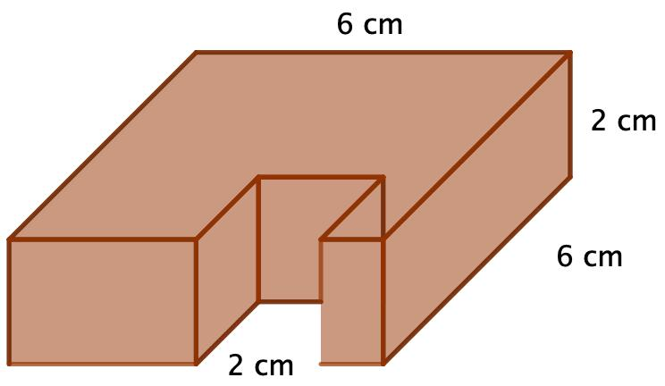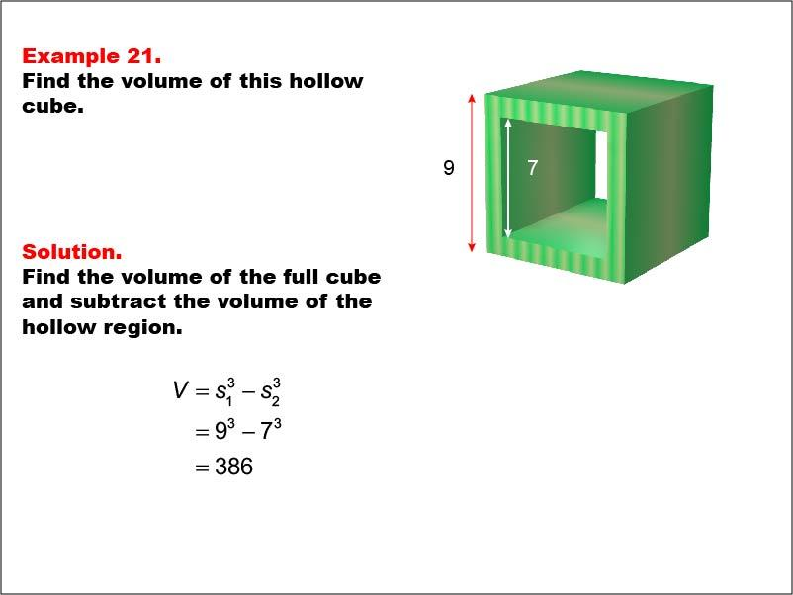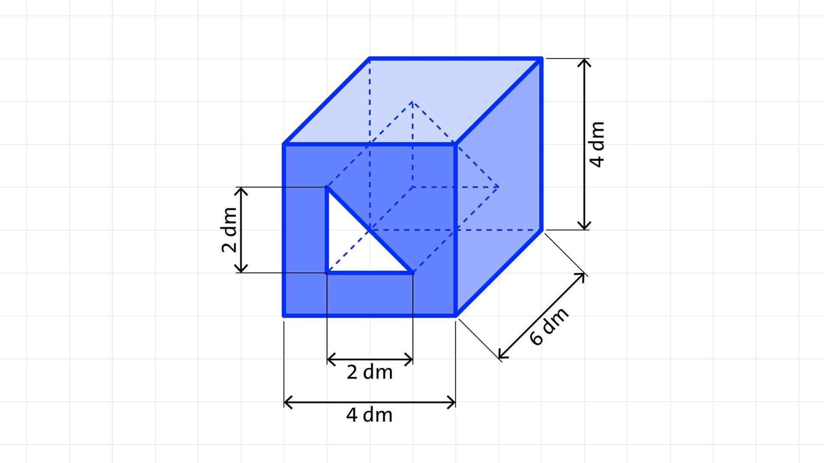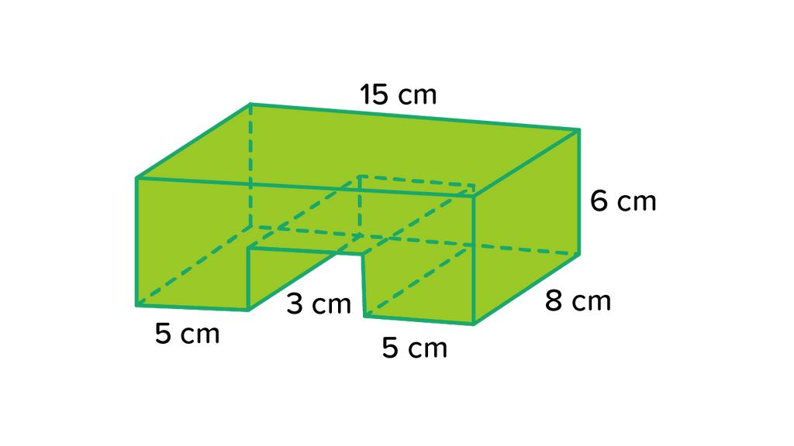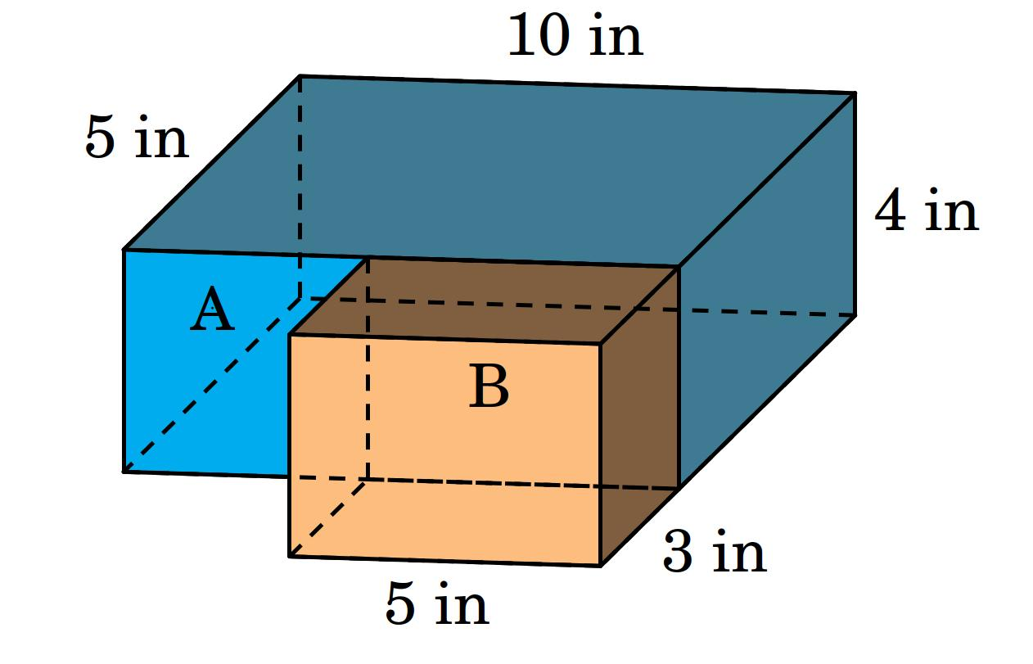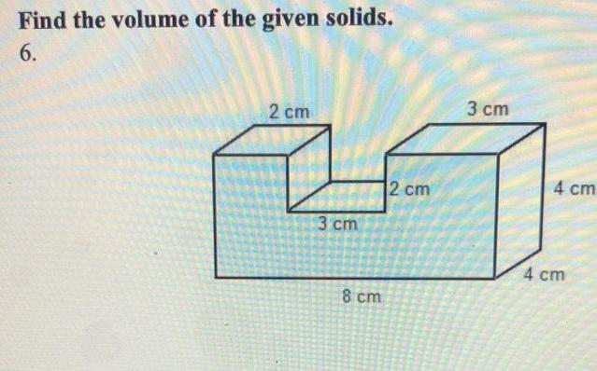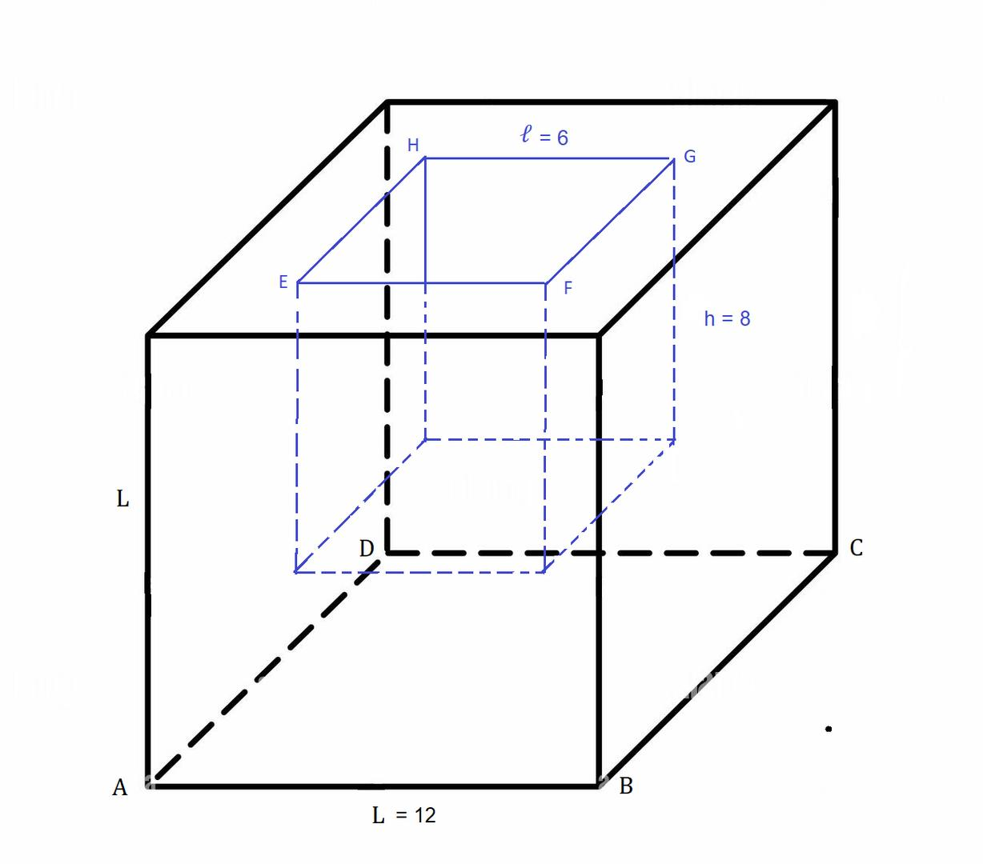
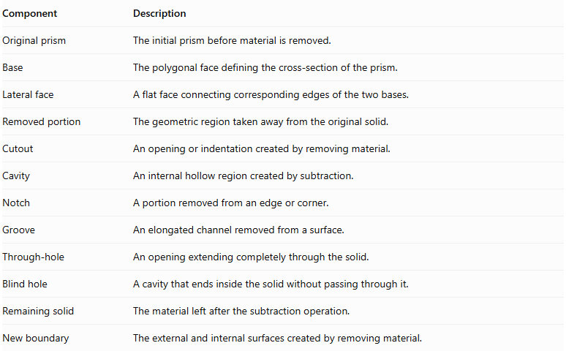
Component | Description
Original prism | The initial prism before material is removed.
Base | The polygonal face defining the cross-section of the prism.
Lateral face | A flat face connecting corresponding edges of the two bases.
Removed portion | The geometric region taken away from the original solid.
Cutout | An opening or indentation created by removing material.
Cavity | An internal hollow region created by subtraction.
Notch | A portion removed from an edge or corner.
Groove | An elongated channel removed from a surface.
Through-hole | An opening extending completely through the solid.
Blind hole | A cavity that ends inside the solid without passing through it.
Remaining solid | The material left after the subtraction operation.
New boundary | The external and internal surfaces created by removing material.

Types of Prism-Based Subtraction

Rectangular Prism Subtraction
# Source: AI Source: Provided by: [Data Path: Persons Table -> ID Column: 1, Name_En Column: Motasem Essam] -> From: [ChatGPT] on [7/25/2026]
This type is formed by removing a rectangular prism or cuboid-shaped portion from an original prism.
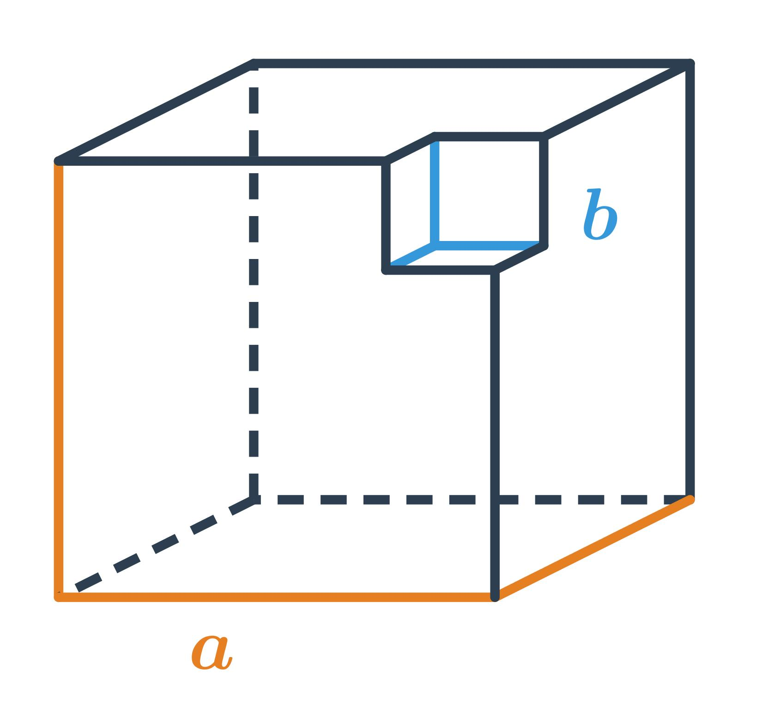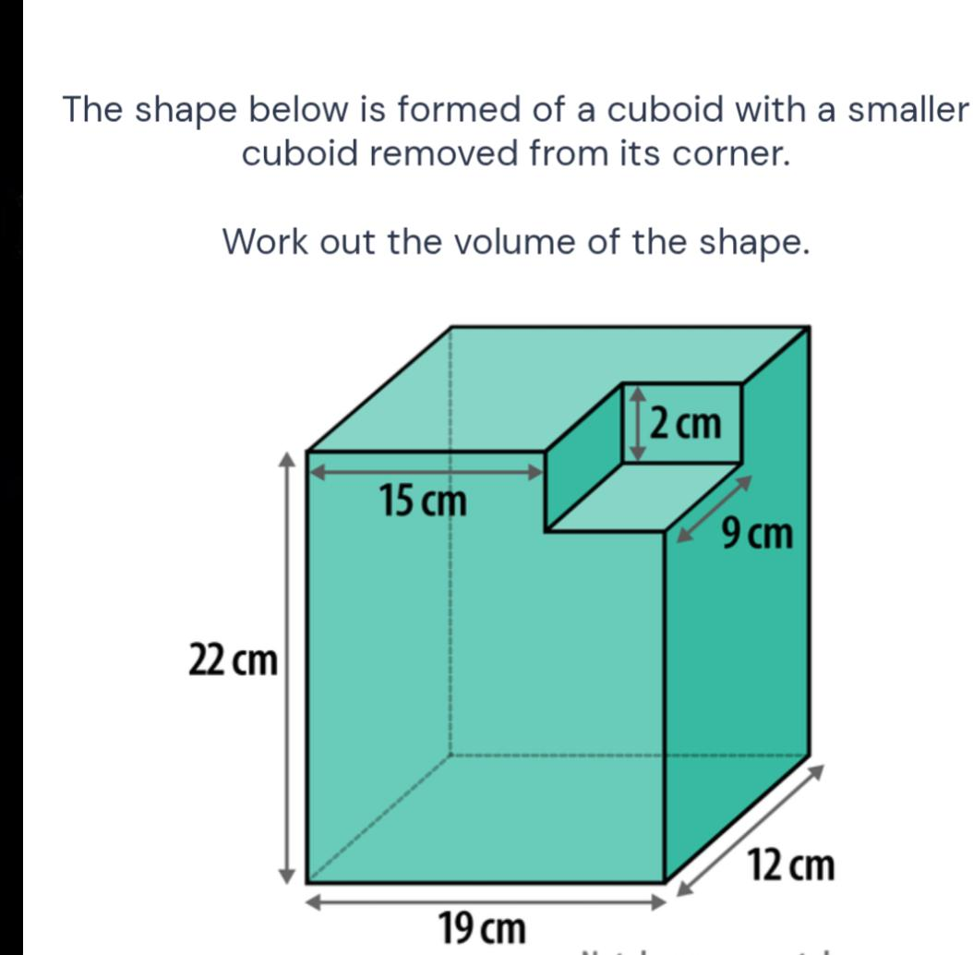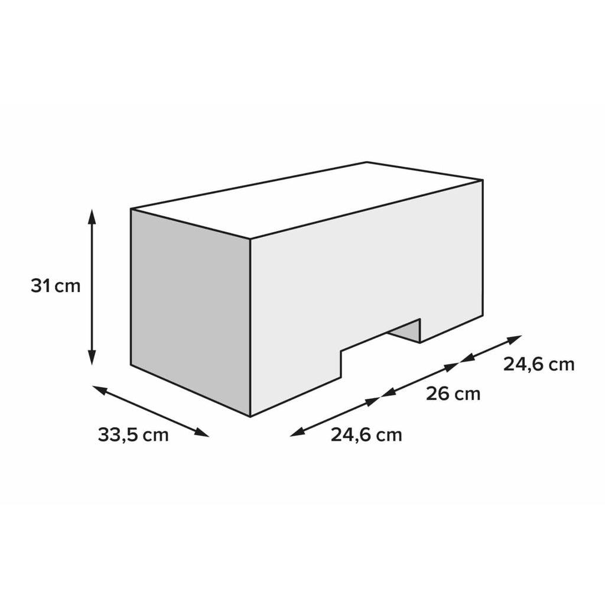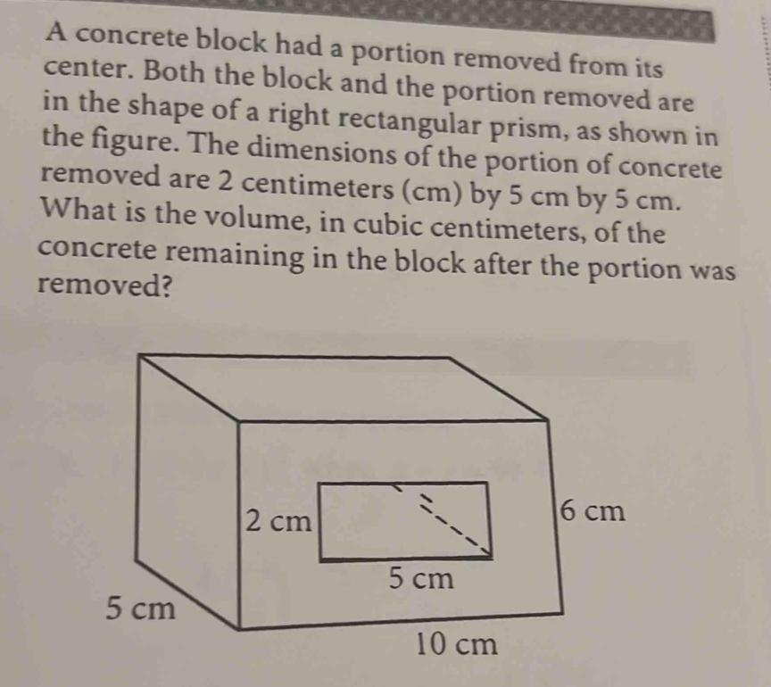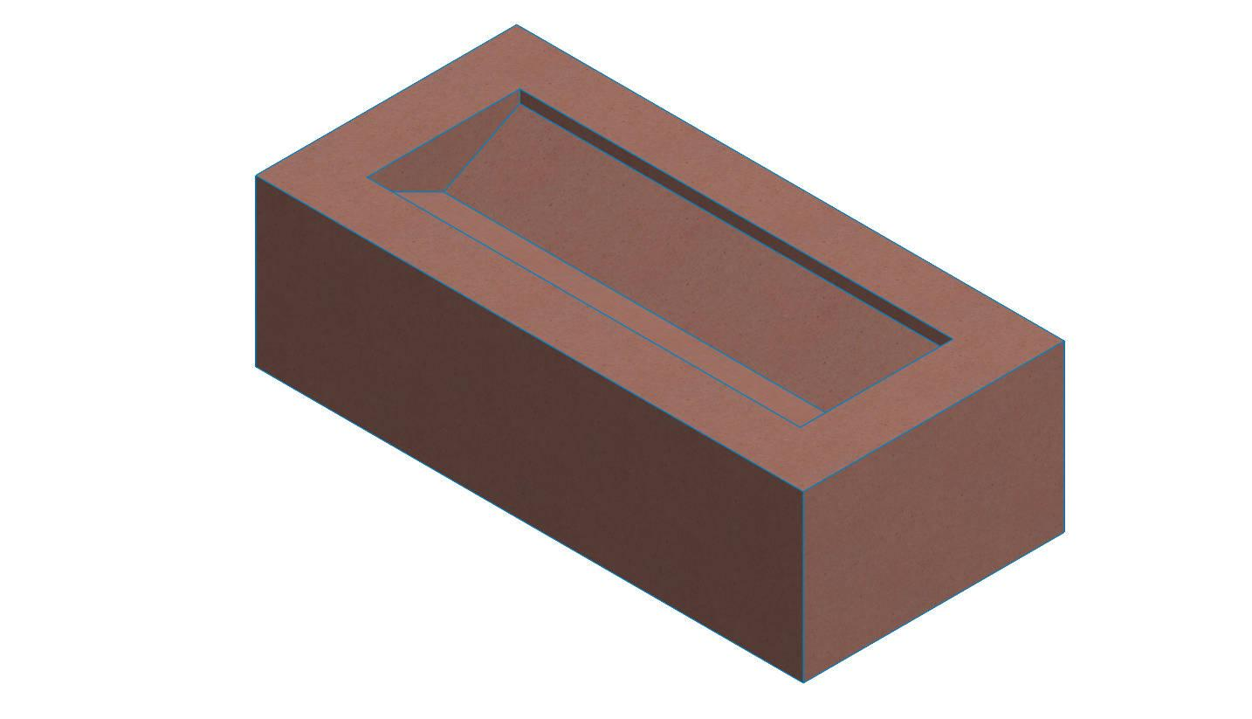
Examples:
- Removing a smaller rectangular block from a corner.
- Creating a rectangular cavity inside a larger prism.
- Removing a rectangular section from the side.
- Creating a stepped rectangular structure.

Cube-Based Subtraction
# Source: AI Source: Provided by: [Data Path: Persons Table -> ID Column: 1, Name_En Column: Motasem Essam] -> From: [ChatGPT] on [7/25/2026]
This type is formed by removing one or more cube-shaped portions from a prism.
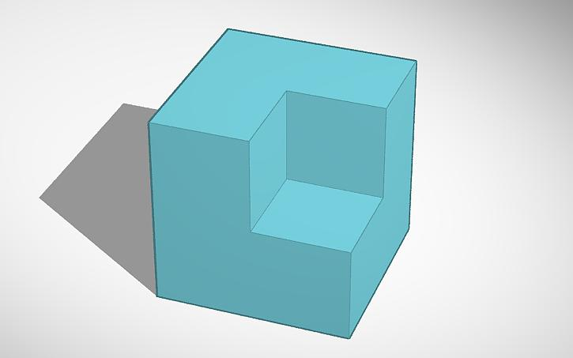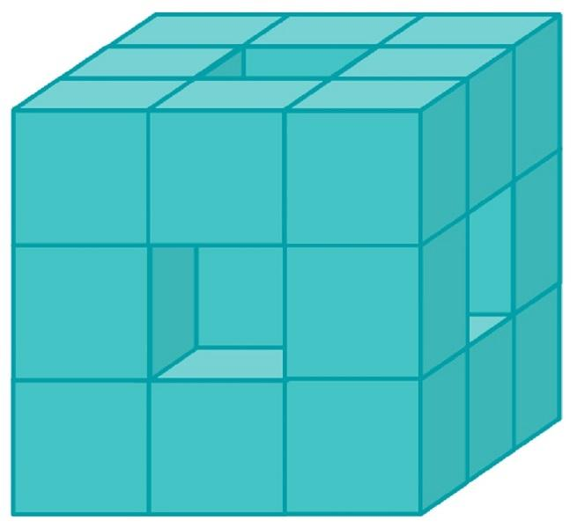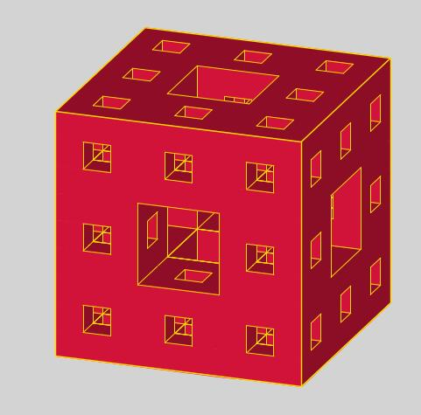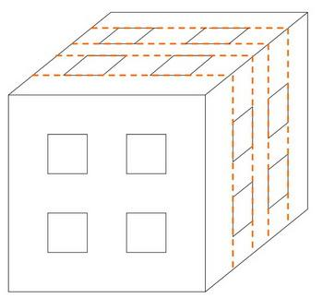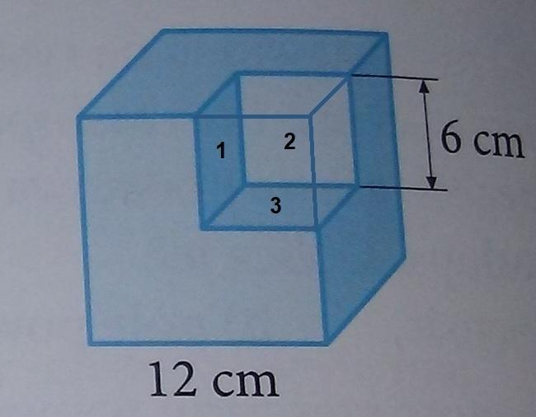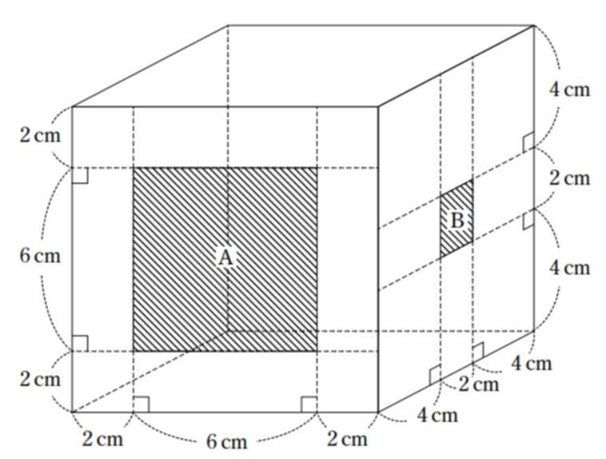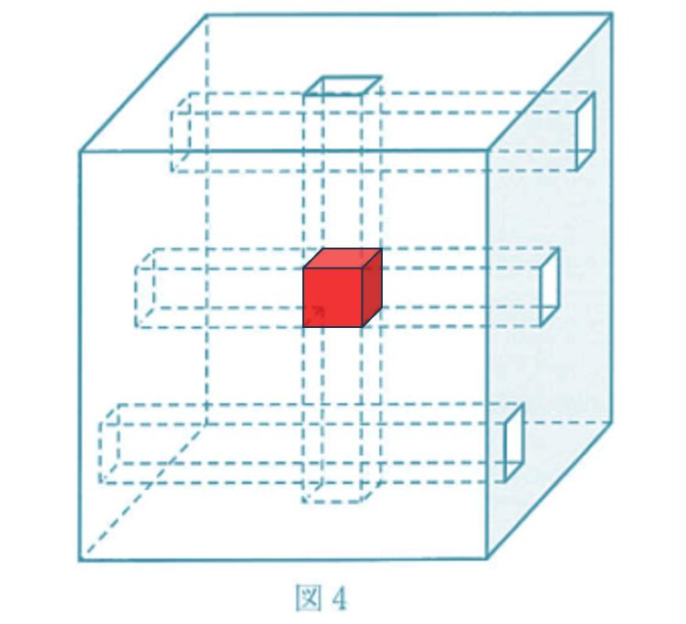
Examples:
- Removing a smaller cube from a larger cube.
- Creating a cubic cavity.
- Removing several cubes from different faces.
- Creating a stepped or block-patterned structure.

Triangular Prism Subtraction
# Source: AI Source: Provided by: [Data Path: Persons Table -> ID Column: 1, Name_En Column: Motasem Essam] -> From: [ChatGPT] on [7/25/2026]
This type is formed by removing a triangular prism-shaped portion from an original prism.
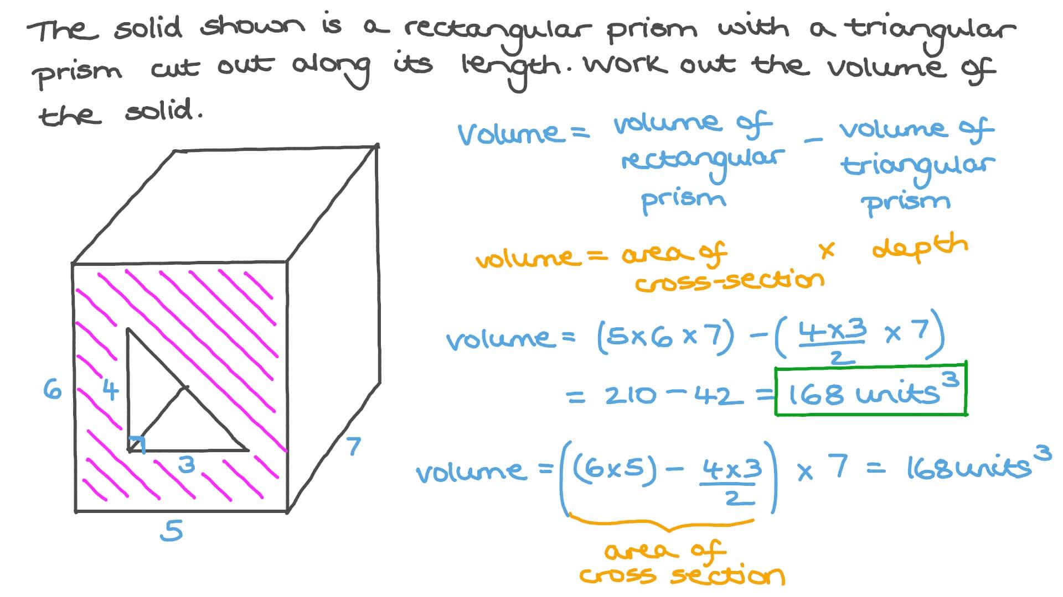
Examples:
- Removing a triangular prism from the side.
- Creating a V-shaped longitudinal groove.
- Removing a triangular section from a corner.
- Creating a sloped channel through a prism.

Polygonal Prism Subtraction
# Source: AI Source: Provided by: [Data Path: Persons Table -> ID Column: 1, Name_En Column: Motasem Essam] -> From: [ChatGPT] on [7/25/2026]
This type is formed by removing a prism with a polygonal cross-section from an original prism.
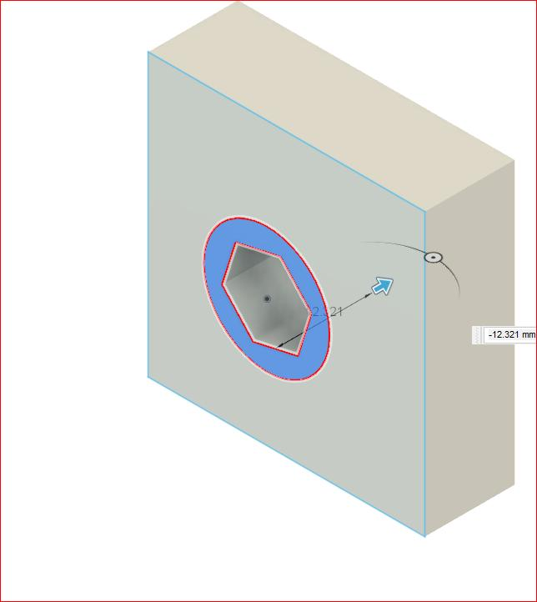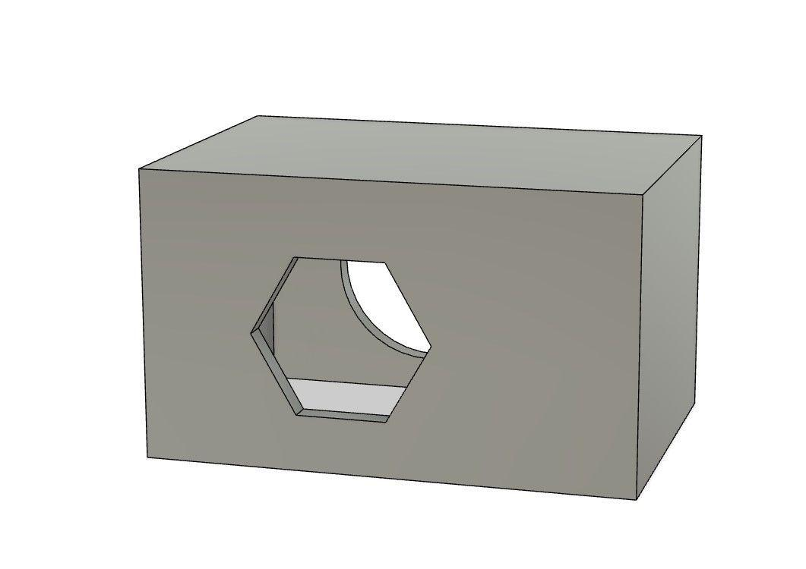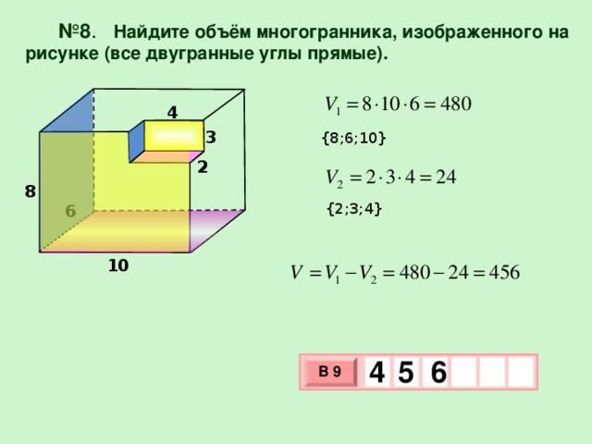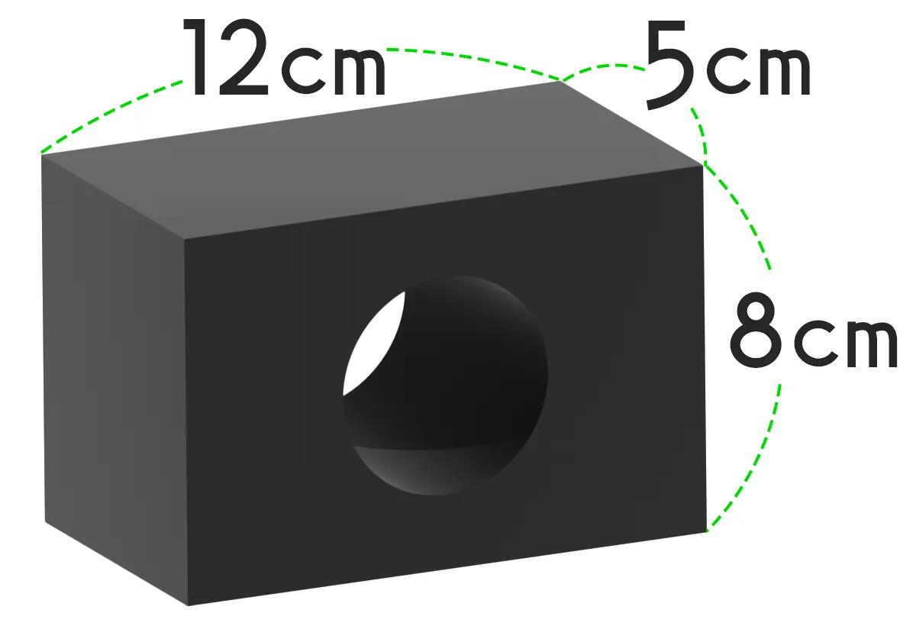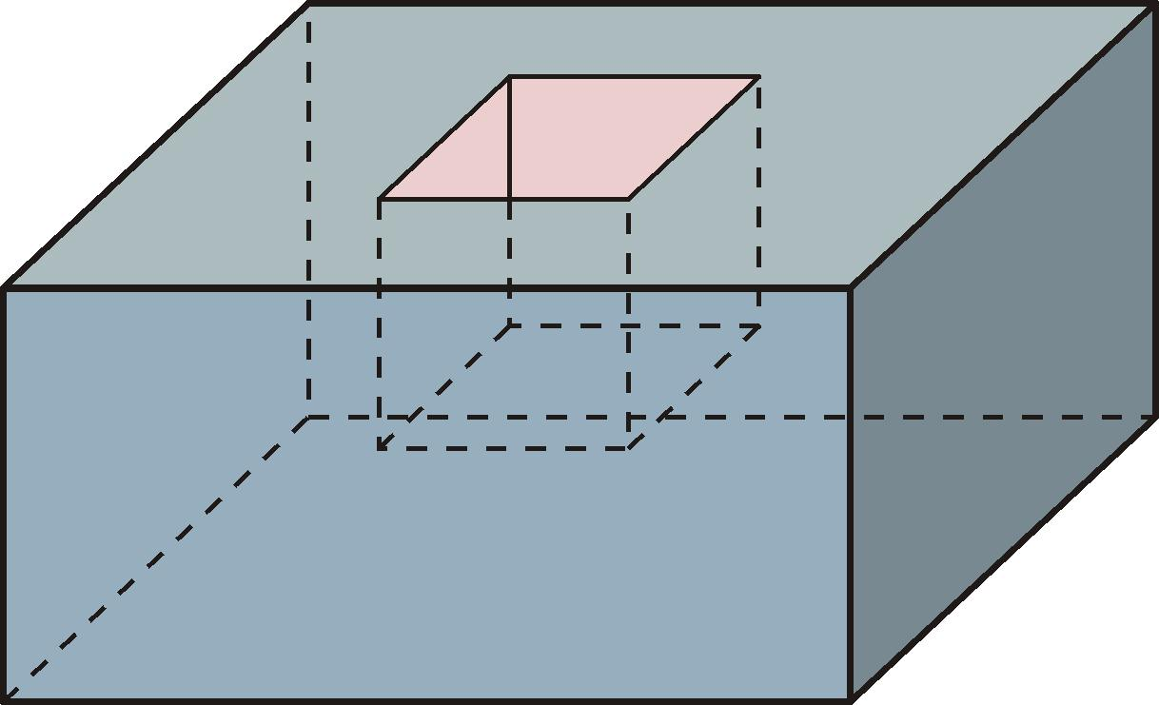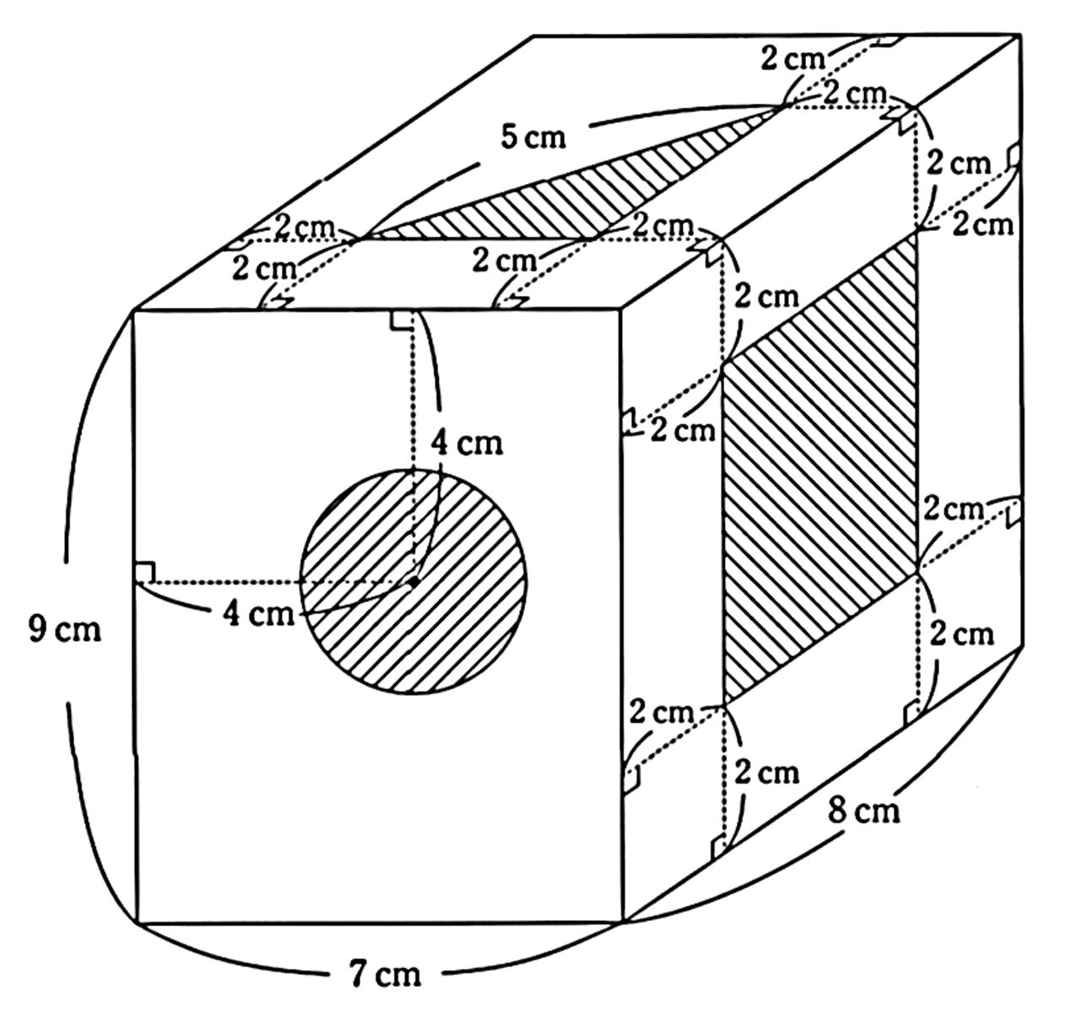
Examples:
- Removing a pentagonal prism-shaped tunnel.
- Creating a hexagonal channel.
- Removing a polygonal section from a side.
- Creating a polygonal cavity.

Cylindrical Subtraction from a Prism
# Source: AI Source: Provided by: [Data Path: Persons Table -> ID Column: 1, Name_En Column: Motasem Essam] -> From: [ChatGPT] on [7/25/2026]
This type is formed by removing a cylindrical portion from an original prism.
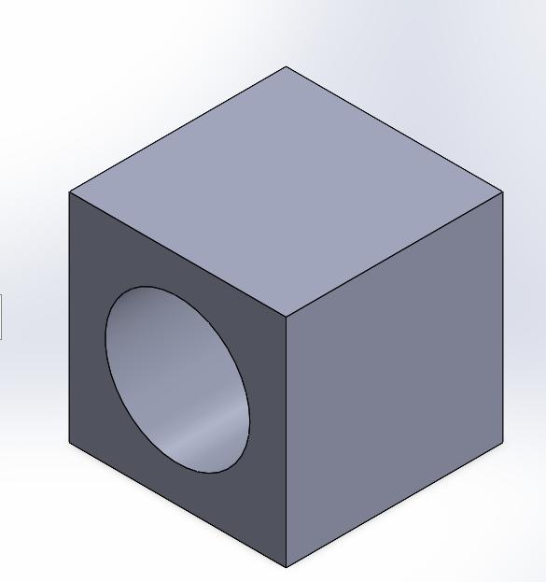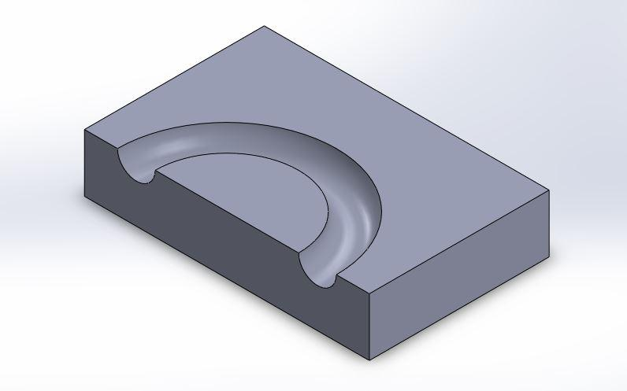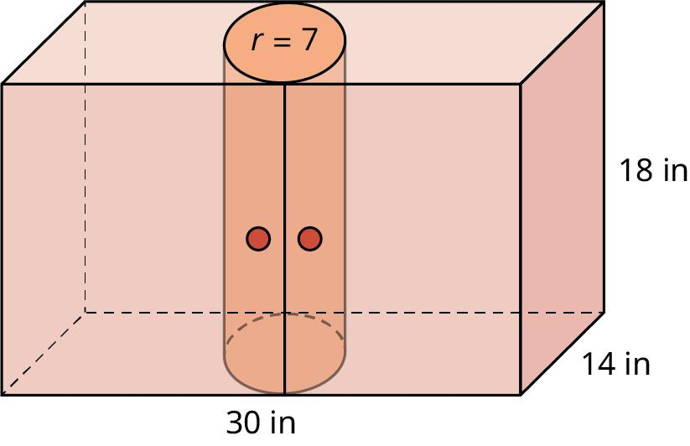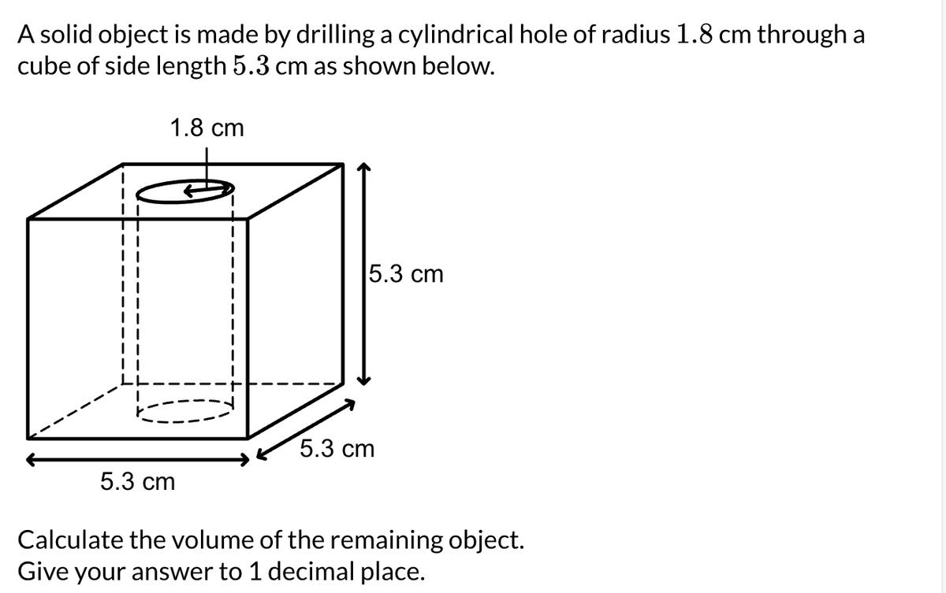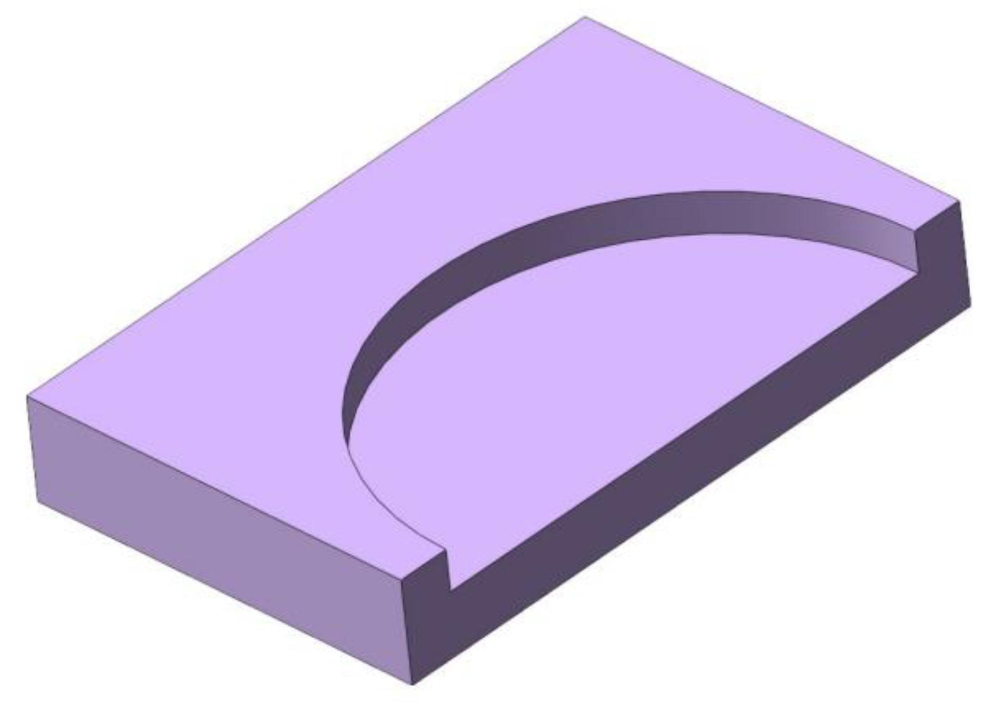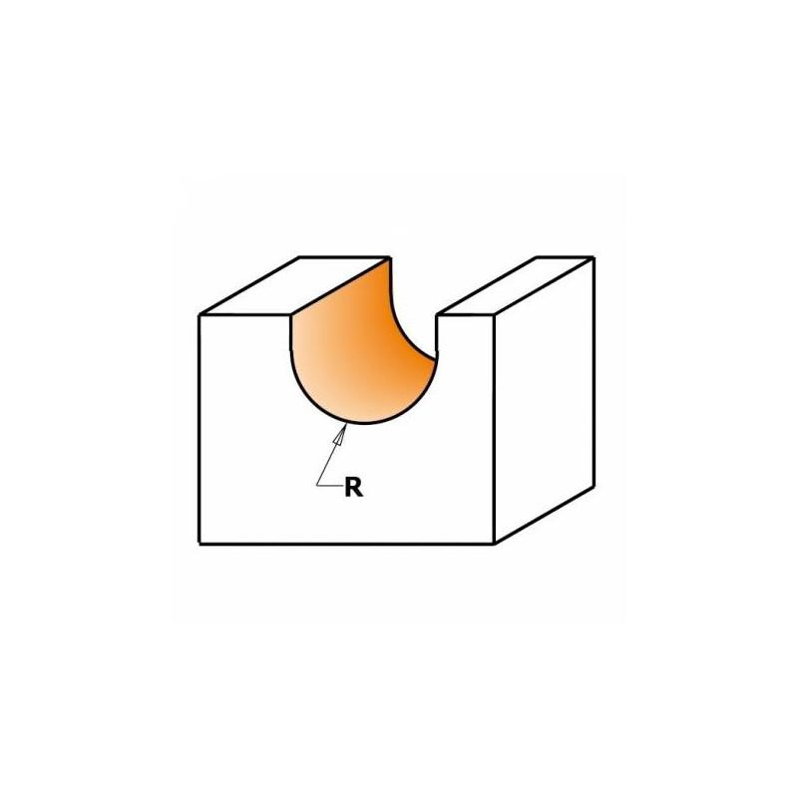
Examples:
- Creating a cylindrical through-hole.
- Creating a cylindrical blind hole.
- Removing a semicylindrical groove.
- Creating multiple cylindrical openings.

Conical Subtraction from a Prism
# Source: AI Source: Provided by: [Data Path: Persons Table -> ID Column: 1, Name_En Column: Motasem Essam] -> From: [ChatGPT] on [7/25/2026]
This type is formed by removing a cone-shaped portion from an original prism.
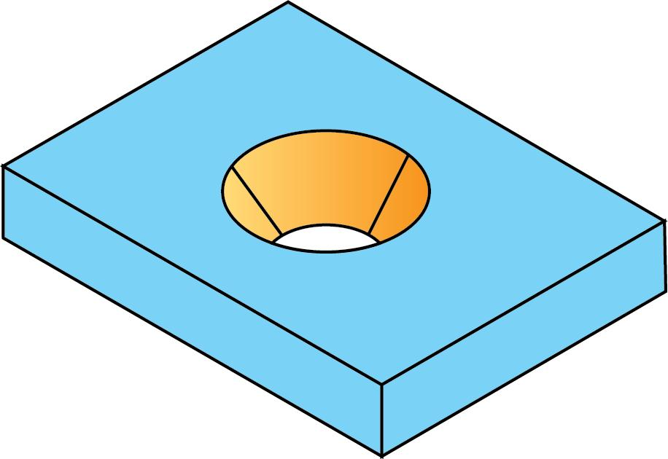
Examples:
- Creating a conical cavity.
- Removing a cone-shaped depression from the top.
- Creating a conical opening.
- Removing a truncated conical section.

Pyramidal Subtraction from a Prism
# Source: AI Source: Provided by: [Data Path: Persons Table -> ID Column: 1, Name_En Column: Motasem Essam] -> From: [ChatGPT] on [7/25/2026]
This type is formed by removing a pyramid-shaped portion from an original prism.
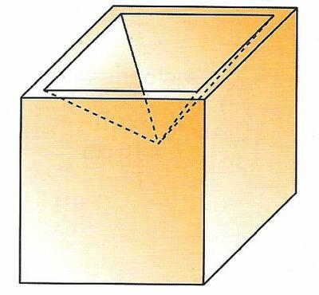
Examples:
- Creating a square pyramidal cavity.
- Removing a triangular pyramid from a corner.
- Creating a pyramid-shaped depression.
- Removing multiple pyramidal sections.

Spherical Subtraction from a Prism
# Source: AI Source: Provided by: [Data Path: Persons Table -> ID Column: 1, Name_En Column: Motasem Essam] -> From: [ChatGPT] on [7/25/2026]
This type is formed by removing a spherical portion or spherical section from an original prism.
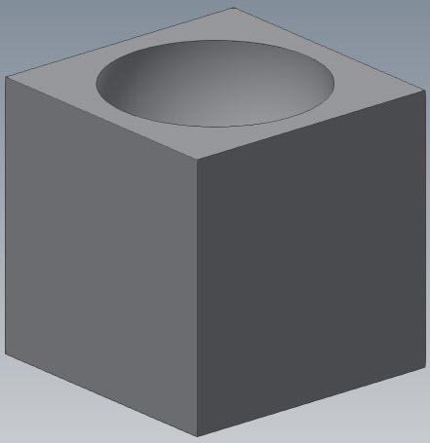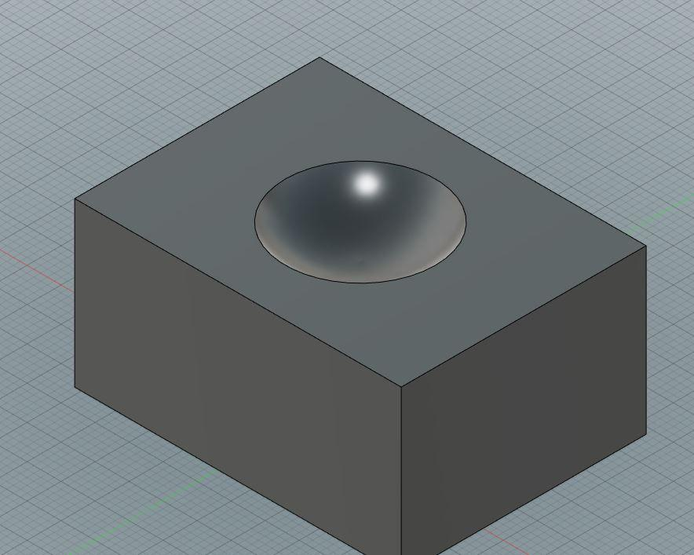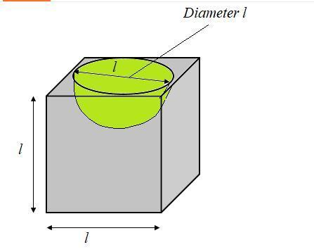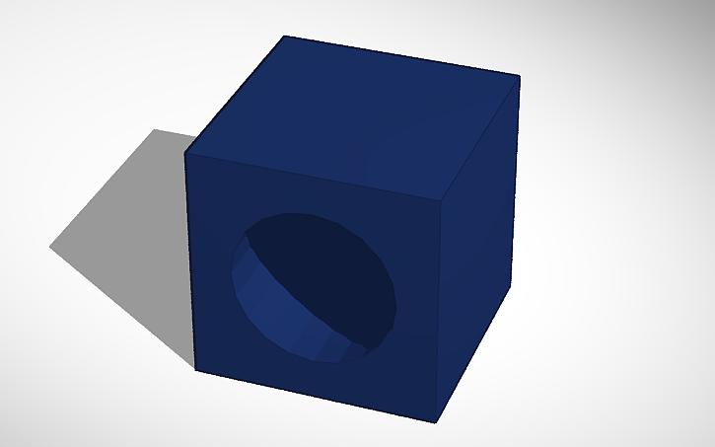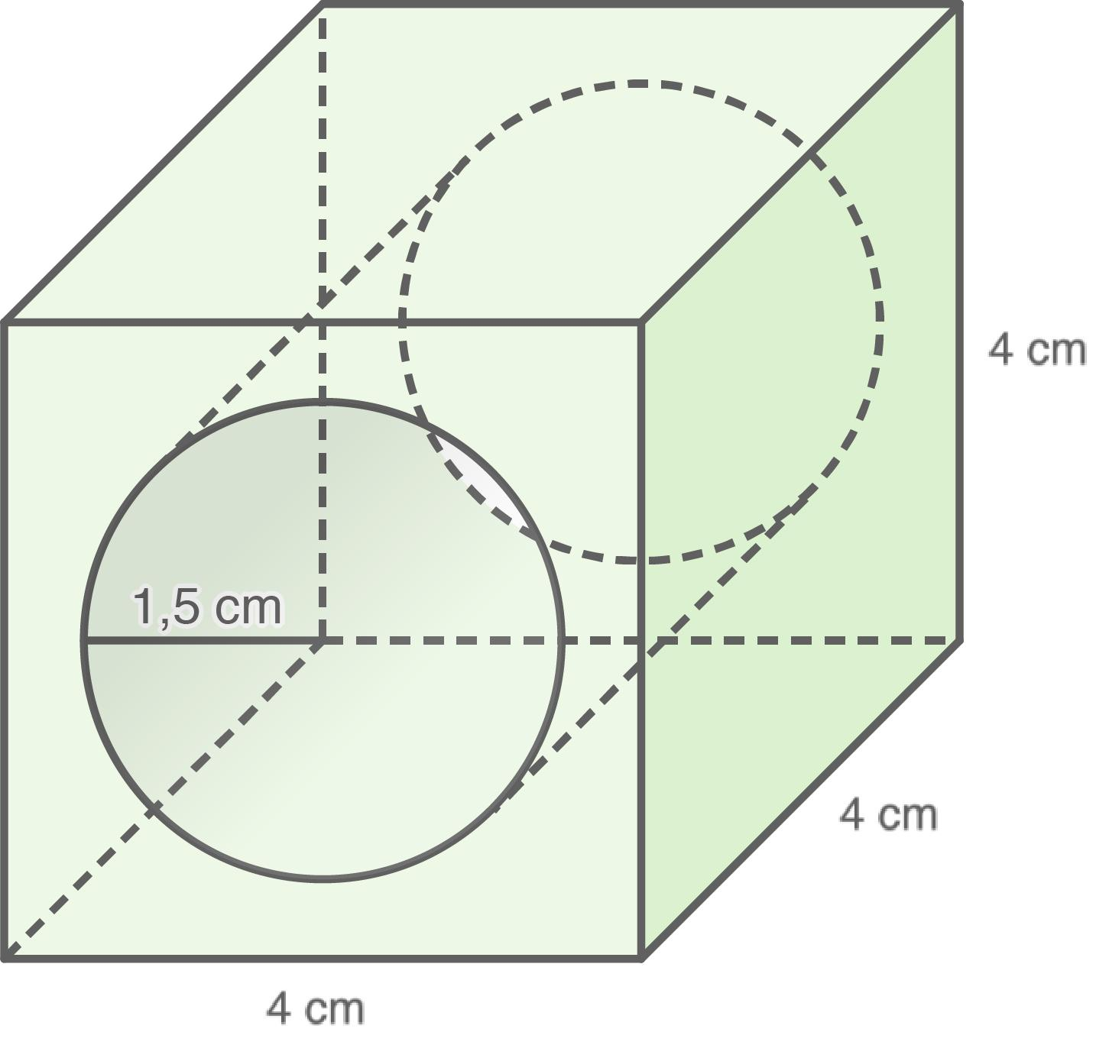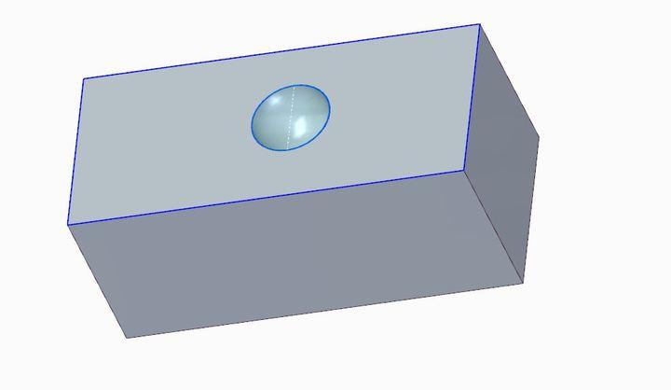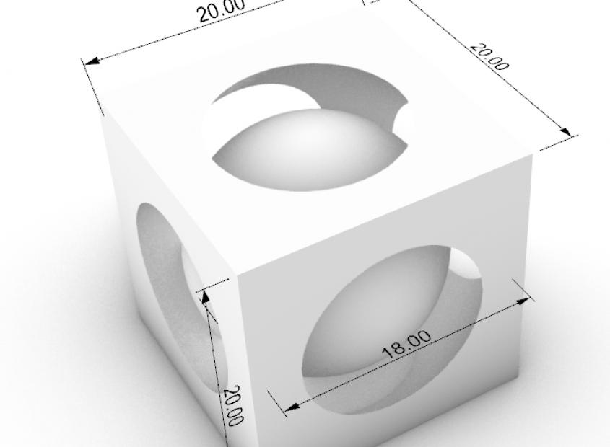
Examples:
- Creating a spherical cavity.
- Removing a hemispherical depression.
- Creating a spherical opening.
- Removing multiple spherical sections.

Multiple-Shape Subtraction from a Prism
# Source: AI Source: Provided by: [Data Path: Persons Table -> ID Column: 1, Name_En Column: Motasem Essam] -> From: [ChatGPT] on [7/25/2026]
This type is formed by removing two or more portions of different geometric shapes from an original prism.
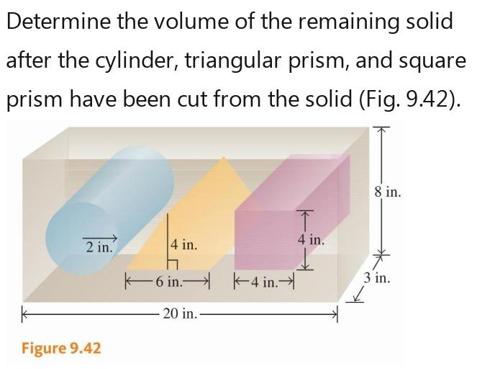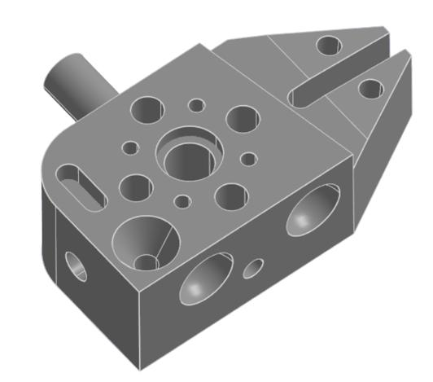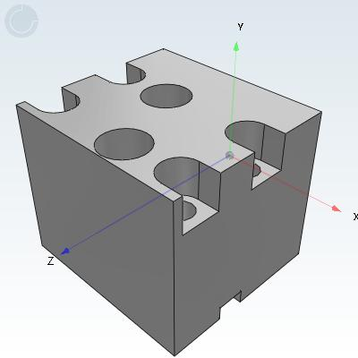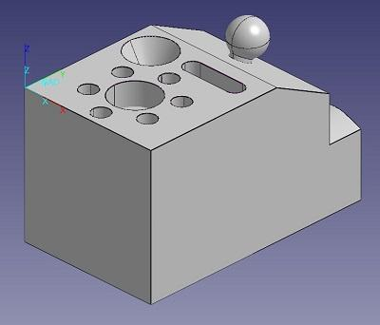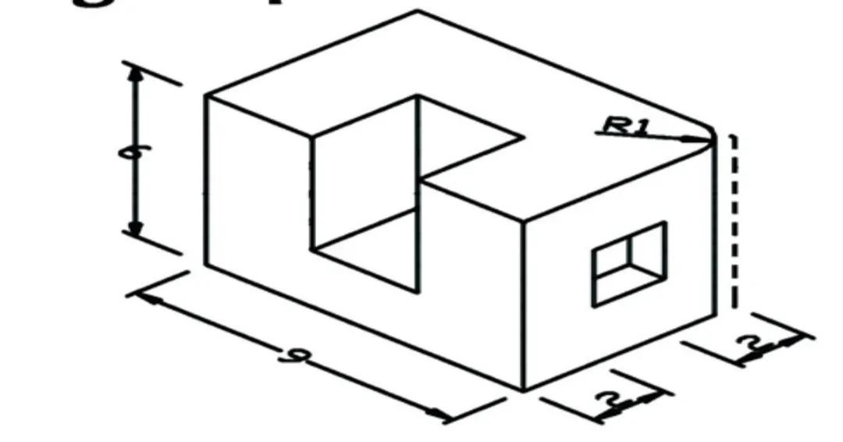
Examples:
- Rectangular cavity + cylindrical hole.
- Triangular notch + rectangular groove.
- Multiple cylindrical and spherical cavities.
- Different polygonal and curved cutouts within one prism.

Classification by Subtraction Location
# Source: AI Source: Provided by: [Data Path: Persons Table -> ID Column: 1, Name_En Column: Motasem Essam] -> From: [ChatGPT] on [7/25/2026]
Prism-based subtraction can also be classified according to where material is removed from the original prism.
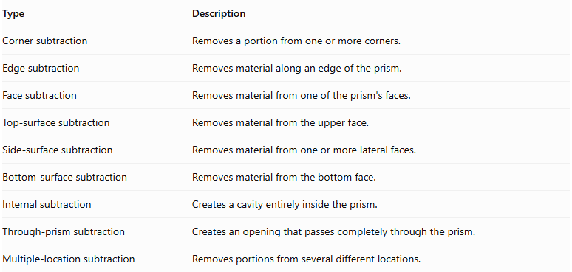
Type | Description
Corner subtraction | Removes a portion from one or more corners.
Edge subtraction | Removes material along an edge of the prism.
Face subtraction | Removes material from one of the prism's faces.
Top-surface subtraction | Removes material from the upper face.
Side-surface subtraction | Removes material from one or more lateral faces.
Bottom-surface subtraction | Removes material from the bottom face.
Internal subtraction | Creates a cavity entirely inside the prism.
Through-prism subtraction | Creates an opening that passes completely through the prism.
Multiple-location subtraction | Removes portions from several different locations.

Classification by Subtraction Method
# Source: AI Source: Provided by: [Data Path: Persons Table -> ID Column: 1, Name_En Column: Motasem Essam] -> From: [ChatGPT] on [7/25/2026]
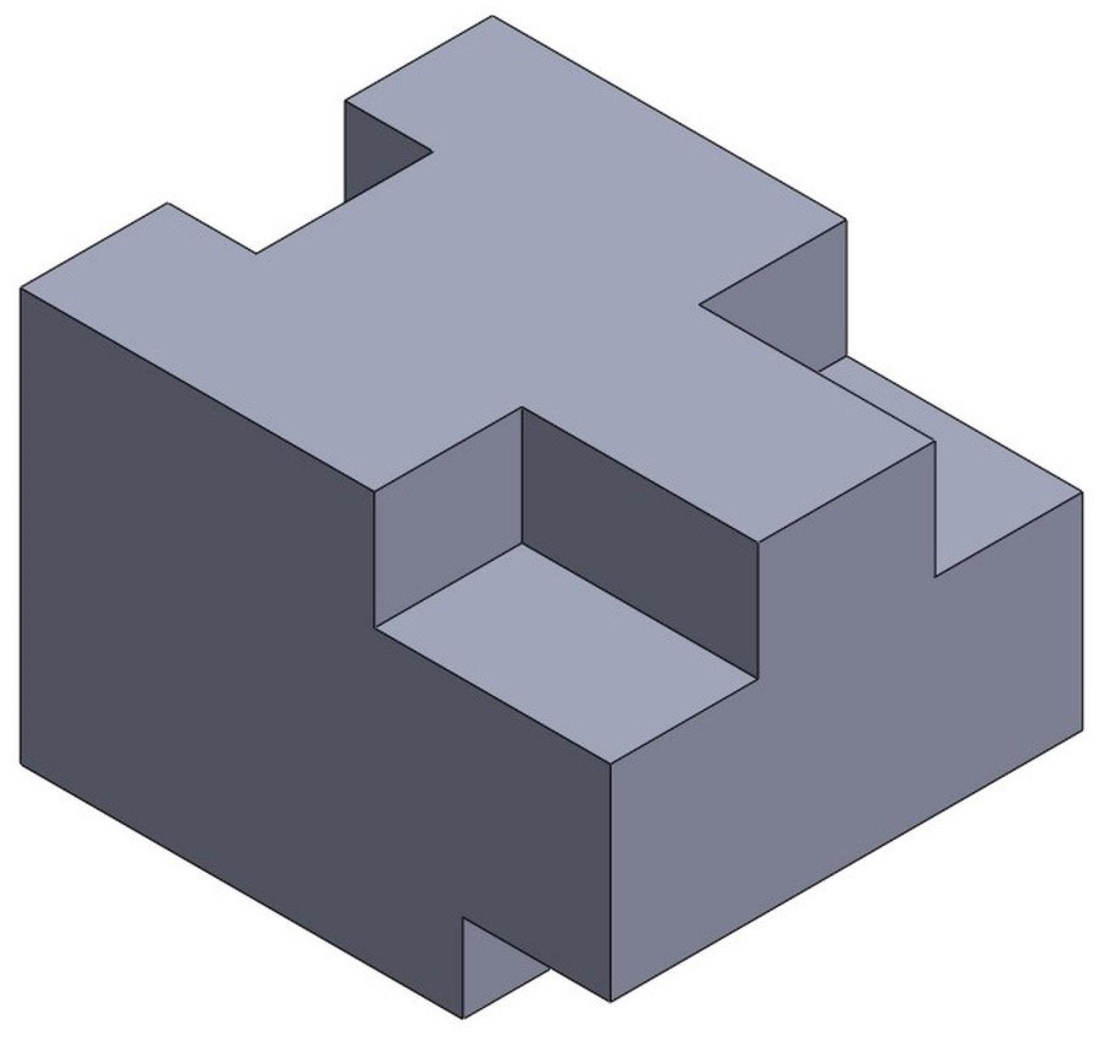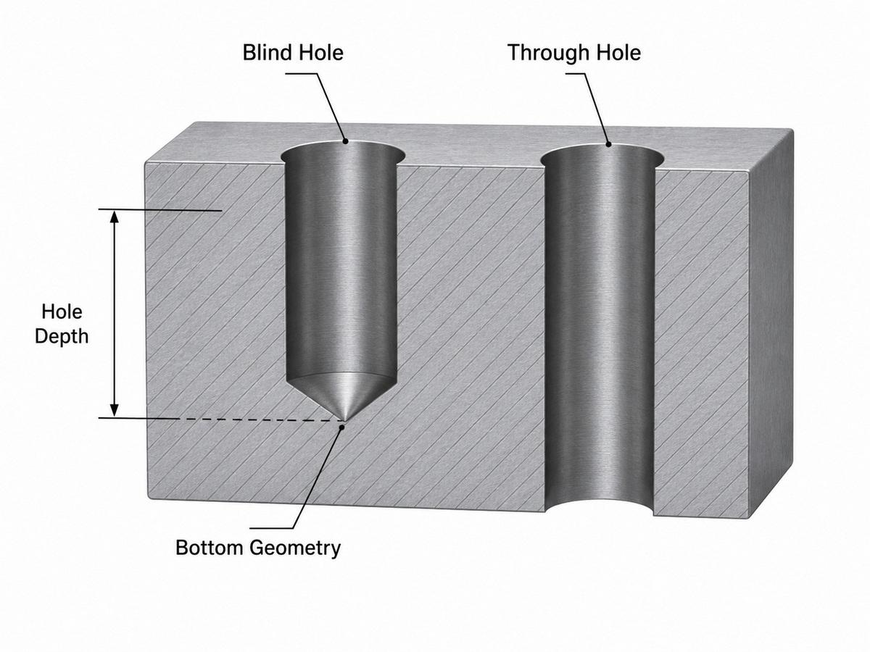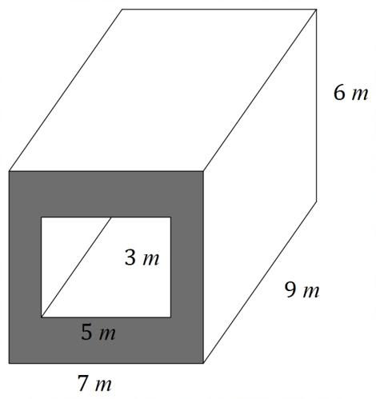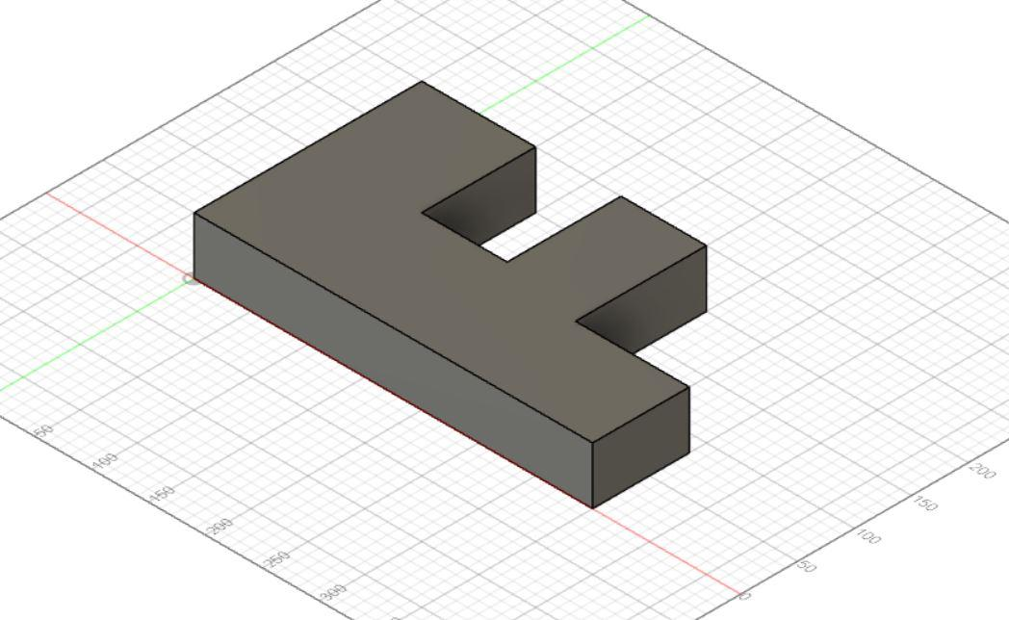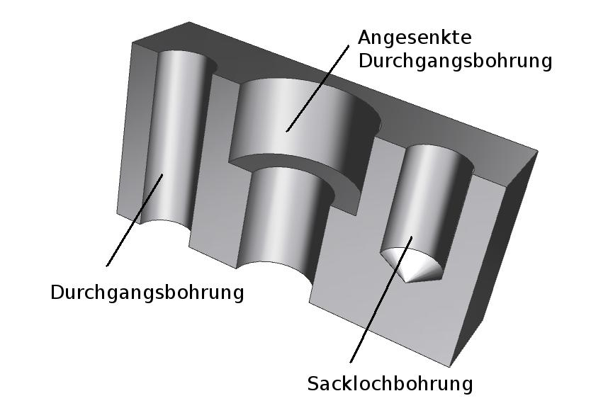
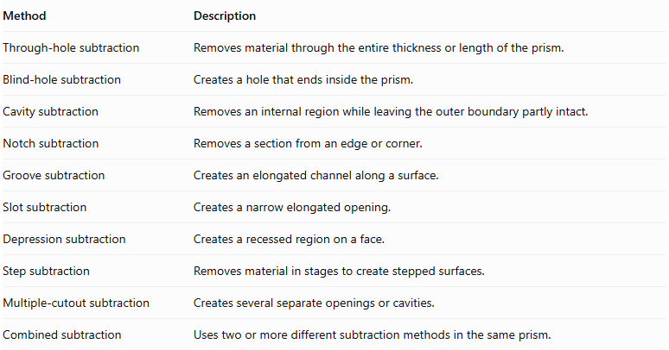
Method | Description
Through-hole subtraction | Removes material through the entire thickness or length of the prism.
Blind-hole subtraction | Creates a hole that ends inside the prism.
Cavity subtraction | Removes an internal region while leaving the outer boundary partly intact.
Notch subtraction | Removes a section from an edge or corner.
Groove subtraction | Creates an elongated channel along a surface.
Slot subtraction | Creates a narrow elongated opening.
Depression subtraction | Creates a recessed region on a face.
Step subtraction | Removes material in stages to create stepped surfaces.
Multiple-cutout subtraction | Creates several separate openings or cavities.
Combined subtraction | Uses two or more different subtraction methods in the same prism.

Classification by Number of Removed Portions
# Source: AI Source: Provided by: [Data Path: Persons Table -> ID Column: 1, Name_En Column: Motasem Essam] -> From: [ChatGPT] on [7/25/2026]
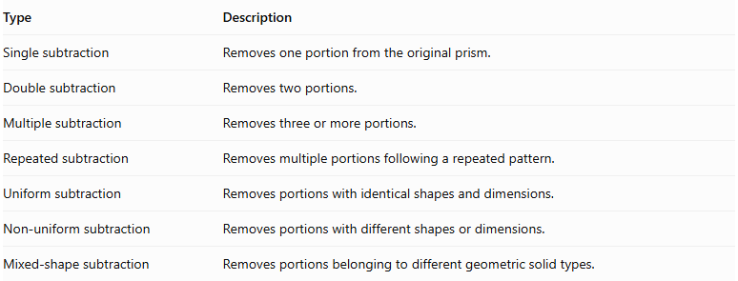
Type | Description
Single subtraction | Removes one portion from the original prism.
Double subtraction | Removes two portions.
Multiple subtraction | Removes three or more portions.
Repeated subtraction | Removes multiple portions following a repeated pattern.
Uniform subtraction | Removes portions with identical shapes and dimensions.
Non-uniform subtraction | Removes portions with different shapes or dimensions.
Mixed-shape subtraction | Removes portions belonging to different geometric solid types.

Mathematical Properties and Formulas

Volume of a Prism-Based Solid After Subtraction
# Source: AI Source: Provided by: [Data Path: Persons Table -> ID Column: 1, Name_En Column: Motasem Essam] -> From: [ChatGPT] on [7/25/2026]
The remaining volume is calculated by subtracting the volume of the removed portions from the original prism volume.
$$\boxed{V_{remaining}=V_{original}-V_{removed}}$$
For multiple removed portions without overlapping regions:
$$V_{remaining}=V_{original}-\sum_{i=1}^{n}{V_{i}}$$
Useful formulas for removed portions:
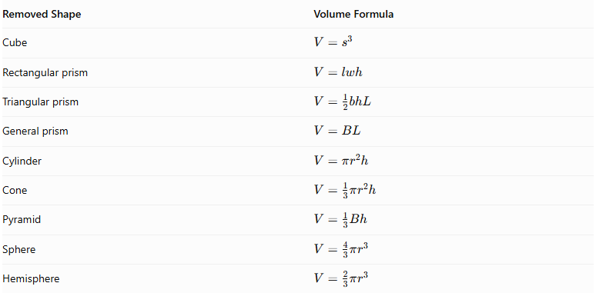
Removed Shape | Volume Formula
Cube | $$V=s^{3}$$
Rectangular prism | $$V=lwh$$
Triangular prism | $$V=\frac{1}{2}bhL$$
General prism | $$V=BL$$
Cylinder | $$V=πr^{2}h$$
Cone | $$V=\frac{1}{3}πr^{2}h$$
Pyramid | $$V=\frac{1}{3}Bh$$
Sphere | $$V=\frac{4}{3}πr^{3}$$
Hemisphere | $$V=\frac{2}{3}πr^{3}$$
Where:
- $B$ = area of the base.
- $L$ = length of a prism.
- $l,w,h$ = rectangular dimensions.
- $r$ = radius.
- $s$ = cube side length.
If removed portions overlap, their intersection must not be subtracted twice.

Surface Area After Subtraction
# Source: AI Source: Provided by: [Data Path: Persons Table -> ID Column: 1, Name_En Column: Motasem Essam] -> From: [ChatGPT] on [7/25/2026]
Unlike volume, surface area cannot generally be calculated by simply subtracting the surface area of the removed solid.
The new surface area depends on:
- The original exposed surfaces that remain.
- The portions of the original surface removed.
- The newly exposed internal walls and curved surfaces.
- The shape, size, and location of each cutout.
The general principle is:
$${SA}_{remaining}={SA}_{original remaining}+{SA}_{newly exposed}$$
For a rectangular prism with a rectangular blind cavity cut into one face:
$${SA}_{remaining}={SA}_{original}-A_{opening}+A_{cavity bottom}+A_{cavity walls}$$
For a cylindrical through-hole passing through a prism:
$${SA}_{remaining}={SA}_{original}-2πr^{2}+2πrh$$
This last formula assumes the cylindrical hole passes completely through two parallel faces, with no interference from the prism's edges or other cutouts.

Worked Examples

Example 1: Rectangular Prism with a Rectangular Blind Cavity
# Source: AI Source: Provided by: [Data Path: Persons Table -> ID Column: 1, Name_En Column: Motasem Essam] -> From: [ChatGPT] on [7/25/2026]
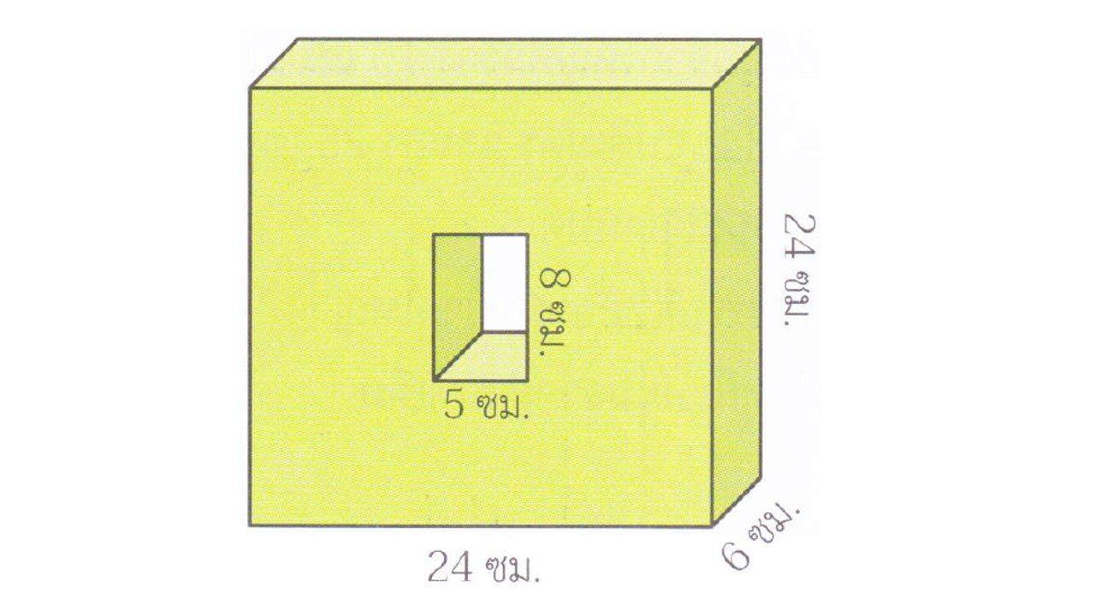
Given:
- Original rectangular prism:
- Length = $12 cm$.
- Width = $8 cm$.
- Height = $6 cm$.
- Rectangular cavity:
- Length = $4 cm$.
- Width = $3 cm$.
- Depth = $2 cm$.
The cavity is cut into the top face without passing through the prism.
Step 1: Calculate the original prism volume.
$$V_{original}=lwh$$
$$=12×8×6=576{ cm}^{3}$$
Step 2: Calculate the removed volume.
$$V_{removed}=4×3×2$$
$$=24{ cm}^{3}$$
Step 3: Calculate the remaining volume.
$$V_{remaining}=576-24$$
$$\boxed{V_{remaining}=552{ cm}^{3}}$$
Step 4: Calculate the original surface area.
$${SA}_{original}=2(lw+lh+wh)$$
$$=2(96+72+48)$$
$$=432{ cm}^{2}$$
Step 5: Calculate the new surface area.
The rectangular opening and cavity bottom have equal areas, so their effects cancel.
The four internal cavity walls add:
$$A_{walls}=2(4×2)+2(3×2)$$
$$=16+12=28{ cm}^{2}$$
Therefore:
$${SA}_{remaining}=432+28$$
$$\boxed{{SA}_{remaining}=460{ cm}^{2}}$$
<badge color="success">Final result</badge>
- Remaining Volume = $552{ cm}^{3}$
- New External Surface Area = $460{ cm}^{2}$

Example 2: Rectangular Prism with a Cylindrical Through-Hole
# Source: AI Source: Provided by: [Data Path: Persons Table -> ID Column: 1, Name_En Column: Motasem Essam] -> From: [ChatGPT] on [7/25/2026]
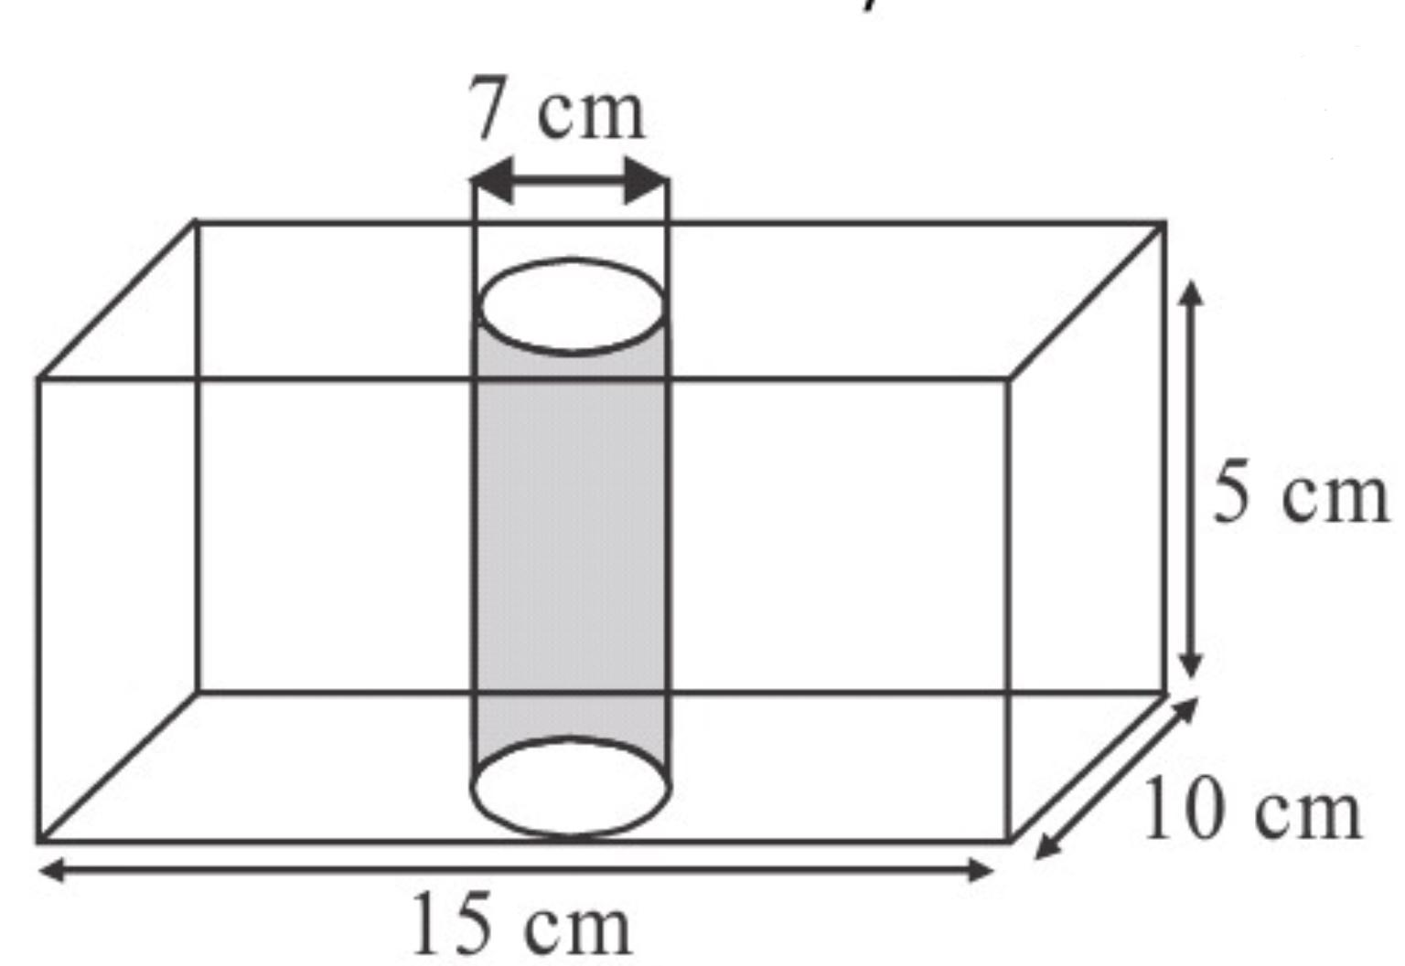
Given:
- Original rectangular prism:
- Length = $10 cm$.
- Width = $8 cm$.
- Height = $6 cm$.
- Cylindrical through-hole:
- Radius = $1.5 cm$.
- Height = $6 cm$.
The cylindrical hole passes vertically through the entire prism.
Step 1: Calculate the original prism volume.
$$V_{original}=10×8×6$$
$$=480{ cm}^{3}$$
Step 2: Calculate the removed cylindrical volume.
$$V_{removed}=πr^{2}h$$
$$=π(1.5)^{2}(6)$$
$$=13.5π{ cm}^{3}$$
Step 3: Calculate the remaining volume.
$$V_{remaining}=480-13.5π$$
$$\boxed{V_{remaining}≈437.59{ cm}^{3}}$$
Step 4: Calculate the original prism surface area.
$${SA}_{original}=2(lw+lh+wh)$$
$$=2(80+60+48)$$
$$=376{ cm}^{2}$$
Step 5: Calculate the new surface area.
The removed cylindrical hole creates:
- Two circular openings on the top and bottom faces.
- One new internal cylindrical curved surface.
Area removed from the original faces:
$$2πr^{2}=2π(1.5)^{2}=4.5π$$
New internal curved surface:
$$2πrh=2π(1.5)(6)=18π$$
Therefore:
$${SA}_{remaining}=376-4.5π+18π$$
$${SA}_{remaining}=376+13.5π$$
$$\boxed{{SA}_{remaining}≈418.41{ cm}^{2}}$$
<badge color="success">Final result</badge>
- Remaining Volume ≈ $437.59{ cm}^{3}$
- New External Surface Area ≈ $418.41{ cm}^{2}$

Important Characteristics
# Source: AI Source: Provided by: [Data Path: Persons Table -> ID Column: 1, Name_En Column: Motasem Essam] -> From: [ChatGPT] on [7/25/2026]
- Original Prism: The starting solid is a prism or a prism-based structure.
- Material Removal: One or more geometric portions are removed from the original solid.
- Variable Cutout Shapes: Removed portions may be rectangular, triangular, polygonal, cylindrical, conical, pyramidal, or spherical.
- Different Cutout Locations: Material can be removed from faces, edges, corners, or internal regions.
- New Internal Surfaces: Subtraction creates additional walls, floors, and curved surfaces.
- Reduced Volume: Removing material decreases the volume of the original solid.
- Variable Surface Area: Surface area may increase or decrease depending on the cutout geometry.
- Through and Blind Openings: Cutouts may pass completely through the prism or end inside it.
- Multiple Cutouts: A single prism may contain several openings or cavities.
- Complex Geometry: Multiple subtraction operations can create complicated three-dimensional structures.

Comparison with Other Types of Composite Solids Formed by Subtraction
# Source: AI Source: Provided by: [Data Path: Persons Table -> ID Column: 1, Name_En Column: Motasem Essam] -> From: [ChatGPT] on [7/25/2026]
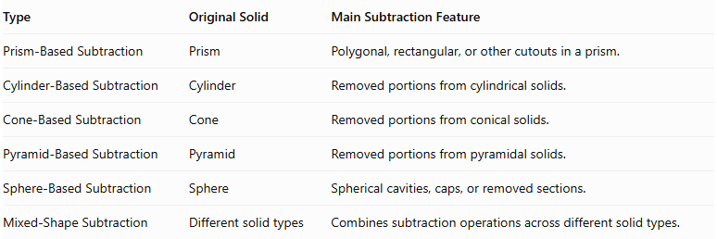
Type | Original Solid | Main Subtraction Feature
Prism-Based Subtraction | Prism | Polygonal, rectangular, or other cutouts in a prism.
Cylinder-Based Subtraction | Cylinder | Removed portions from cylindrical solids.
Cone-Based Subtraction | Cone | Removed portions from conical solids.
Pyramid-Based Subtraction | Pyramid | Removed portions from pyramidal solids.
Sphere-Based Subtraction | Sphere | Spherical cavities, caps, or removed sections.
Mixed-Shape Subtraction | Different solid types | Combines subtraction operations across different solid types.

Applications
# Source: AI Source: Provided by: [Data Path: Persons Table -> ID Column: 1, Name_En Column: Motasem Essam] -> From: [ChatGPT] on [7/25/2026]
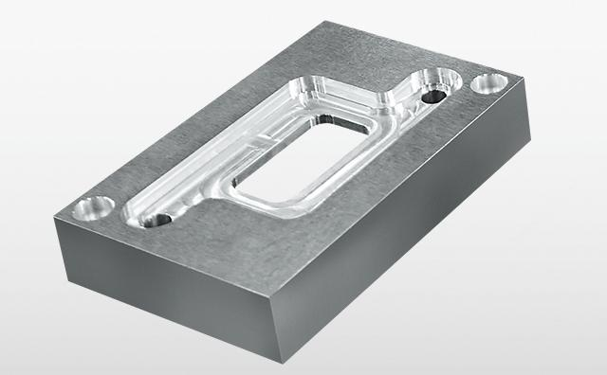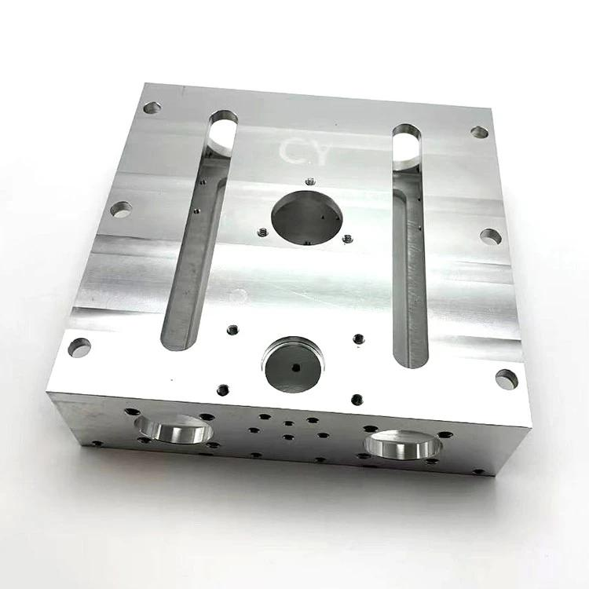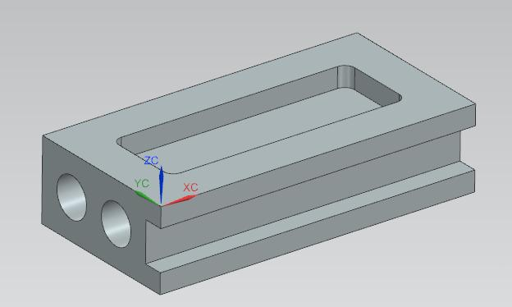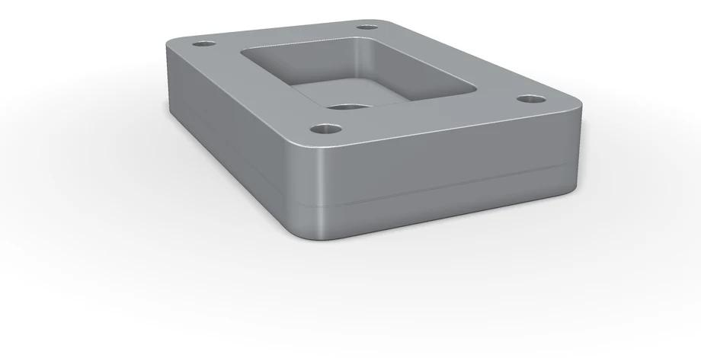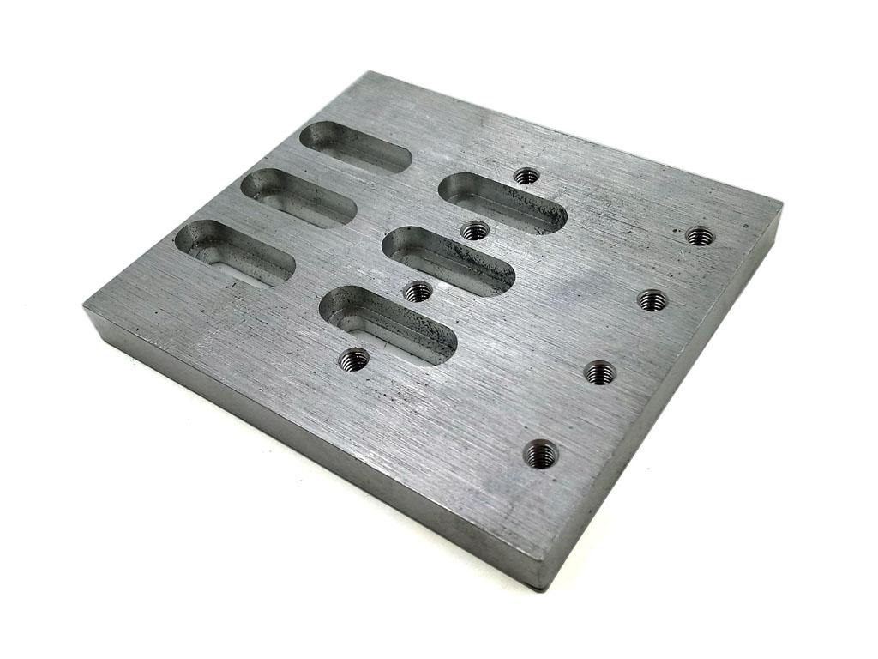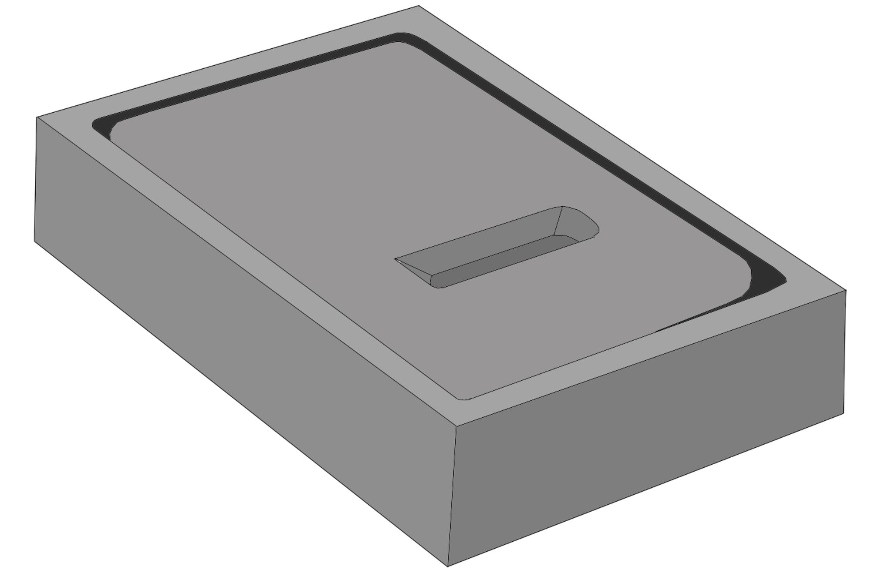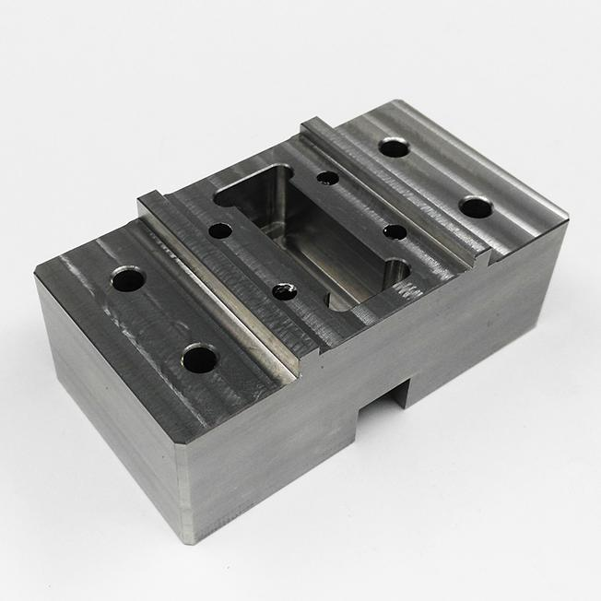
Prism-based subtraction is used in several fields:
- Mechanical Engineering: Creating holes, slots, grooves, and cavities in machine components.
- Manufacturing: CNC milling, drilling, cutting, and machining rectangular blocks.
- Construction: Creating openings and recesses in rectangular structural elements.
- Architecture: Designing recessed walls, stepped structures, and decorative cutouts.
- Product Design: Creating internal compartments and openings in manufactured products.
- Computer-Aided Design (CAD): Modeling complex objects through Boolean subtraction operations.
- Mathematical Education: Teaching volume differences, cross-sections, and surface area changes.

Key Points
# Source: AI Source: Provided by: [Data Path: Persons Table -> ID Column: 1, Name_En Column: Motasem Essam] -> From: [ChatGPT] on [7/25/2026]
- Prism-based subtraction removes one or more portions from an original prism.
- Removed portions can be prisms, cylinders, cones, pyramids, spheres, or other geometric shapes.
- Subtraction can create through-holes, blind holes, cavities, notches, grooves, and depressions.
- The remaining volume is calculated by subtracting the removed volume from the original volume.
- Overlapping removed regions must be handled carefully to avoid double-counting.
- Surface area must account for both removed original surfaces and newly exposed surfaces.
- The surface area does not necessarily decrease when material is removed.
- Multiple subtraction operations can produce complex geometric structures.

Conclusion
# Source: AI Source: Provided by: [Data Path: Persons Table -> ID Column: 1, Name_En Column: Motasem Essam] -> From: [ChatGPT] on [7/25/2026]
Prism-Based Subtraction is an important category of composite solids formed by subtraction. It involves removing geometric portions from an original prism to create new shapes with openings, cavities, grooves, notches, and other structural features.
The removed portions may have different geometric forms and can be positioned at various locations within the original solid. Understanding this process makes it possible to calculate remaining volume, analyze changes in external surface area, and study complex geometric structures used in mathematics, engineering, manufacturing, and computer-aided design.

